

Assessment Cover Page
Student Full | Leonardo Tarulli
Student Number | Sba25074
Module Title | Strategic thinking
Assessment Title | CA-1 Capstone Project Proposal (20%)
Lecturer/Supervisor | Taufique Ahmed
Assessment Due Date | 25/10/2026
Date of Submission | 25/10/2026
Use of AI Tools
I acknowledge the use of Gemini through Google for the purpose of checking for typos, grammatical mistakes, punctuation and commas.
Declaration
By submitting this assessment, I confirm that I have read the CCT policy on academic misconduct and understand the implications of submitting work that is not my own or does not appropriately reference material taken from a third party or other source.
I declare it to be my own work and that all material from third parties has been appropriately referenced.
I further confirm that this work has not previously been submitted for assessment by myself or someone else in CCT College Dublin or any other higher education institution.
ha

Contents
MyMusic - Music Recommendation System 1
Introduction 1
Problem Definition 1
Aim and Objectives 2
Scope 2
Methodology 3
Data Sources 6
Expected Deliverables 6
Project Timeline 7
Ethical and Legal Considerations 7
References 8
Appendix 8

MyMusic - Music Recommendation System

Introduction
MyMusic is a new company which provides online streaming music services. The company offers an app which users can download on their phones, create an account, and play music from different artists either for free with ads or by going premium with a monthly subscription. However, the management has recently found that they could improve customer experience by introducing a new feature aimed at recommending songs to users. This feature will not only help them offer a personalised experience, increase engagement, and grow customer satisfaction, but it will also be a key distinction between them and their competitors. In order to achieve this, the management has decided to create, develop, and implement this through a machine learning model, and they have sent the project to the data department to start it.

Problem Definition
Thinking about my proposal, I can say that some of the challenges I will address are:
- “What outcome do I want to predict?” I must think deeply about this to know how to proceed with the project.
- “What variables/features do I have to select to train my model?” – Understanding and identifying the variables that will best perform in my model is crucial towards obtaining the desired outcome (which is that the final user likes the recommended song).
- “How do I have to process my selected features?” – I will be working with different types of variables and, to train my machine learning algorithms, I might have to execute encoding. I need to be certain about how I will do this to obtain an efficient and effective model.
Data analytics and predictive modelling offer me different resources and techniques for addressing the mentioned problems and building my desired system. “Data Analytics helps us turn raw data into faster decisions, lower costs, and a better customer experience” (CCT College Word Document – Strategic thinking: Week 2 | 2026).
With regard to Predictive Modelling, it provides me with several types of machine learning models capable of predicting different results depending on the outcome I want to achieve, the type of data I insert to train the model with, and the different values I can pass to the model parameters.

Aim and Objectives
The major aim of this project is to upgrade customer experience for my current and potential clients by offering a personalised service and increasing customer satisfaction.
The aim of this project will be addressed by the following achievable objectives:
- Identify the outcome: Before starting to work with my data, I should identify what outcome I want to obtain to correctly select an approach for data management and select the appropriate machine learning model.
- Understand Customer Patterns: Identifying this is crucial for our project. if I know what patterns I can use to recommend new songs to the customers, I can start working on training my machine learning model and implementing a prototype.
- Check results obtained: Once I have my data ready and the model trained, I should check the results obtained and see what accuracy I obtained with respect to the desired outcome, precision and recall. In other words, I should test the model and see if it’s working as desired.

Scope
In the first semester, I will include all the work in relation to data research, investigation, and exploration of different music datasets on different platforms. I will also dig into understanding my dataset, looking for patterns, correlations, and relationships between the distinctive features, and deciding which machine learning model will be the best for my desired outcome.
In the second semester, I will start working on my machine learning model by training it, checking and comparing predicted results (Accuracy, F1, Recall, Precision, etc.), and making any relevant changes to its parameters to improve it. Once I finish this, I will do a final test and send it to production.

Methodology
- Data Analytics Tools
In terms of Data Analytics tools, I propose the use of Anaconda software for its flexibility and open-source property. I can make use of Jupyter Notebook, a tool designed to write and execute Python code, through which I can import the necessary libraries for the project (e.g., Pandas, NumPy, Scikit-learn, Matplotlib, and Seaborn), clean, preprocess, and encode my data for further building, training, and testing of several machine learning models (such as Decision Tree Classifier, Knn values, Random Forest, etc). I also propose the use of different data sources in CSV file format from Kaggle and Google Data Search.
- Data Cleaning Methods
Regarding data cleaning methods, I propose to drop duplicate records, rename columns, trim and replace values if needed, and execute different encoding techniques depending on the column worked. For example:
- If I am dealing with a variable that is a Boolean (only “Yes,” “No” values), I will apply Label Encoder
- If I am working with variables that have a meaningful order or rank, I will apply Mapping.
- And finally, if I am working with non-ordinal features that do not have a meaningful order, I will apply One Hot Encoder
The reason for these techniques in the encoding stage is to secure a high-quality result, since Label Encoder is mostly used for Boolean features that only have 2 unique values and retrieves only “0s” and “1s”. About One Hot Encoder, it’s used to prevent the model from assuming any type of mathematical hierarchy or distance between categories (e.g., there is no relevant difference between “Cat”, “Dog”, and “Lamb”, but if my model reads “1”,”2”, and ”3”, it could think that the number 3 has some higher importance than 1 and 2, which is not the case). Finally, for mapping, I will use it to set Ordinal Variables Accordingly, making sure that the order between the values is correct (e.g., a feature containing the values “Employee”, “Team leader”, “Manager” and “Region Manager”).
Data Preparation Module (2026). Week 3: Encoding Categorical Data PDF - CCT College Dublin (22nd of October 2026)

- Predictive Modelling Techniques
At the stage of Predictive Modelling, since I will be working with music metadata and my final desired outcome is to predict/recommend an unknown song based on the user’s reproduction history. I believe that the best model I can use is Clustering.
“1. The quickest way to choose a machine learning model: 4 questions
4º Do I have no target and want to discover similar groups? Clustering” (CCT College Word Document – Strategic thinking: Week 2 | 2026)
However, I am open to try other machine learning models such as Random Forest, AdaBoost, and XGBoost. Since I will be able to identify what type of characteristics the user like within a song (e.g., BPM, Danceability, Energy, Etc.) However, I will not be closed to using other models that could perform better than those previously mentioned.
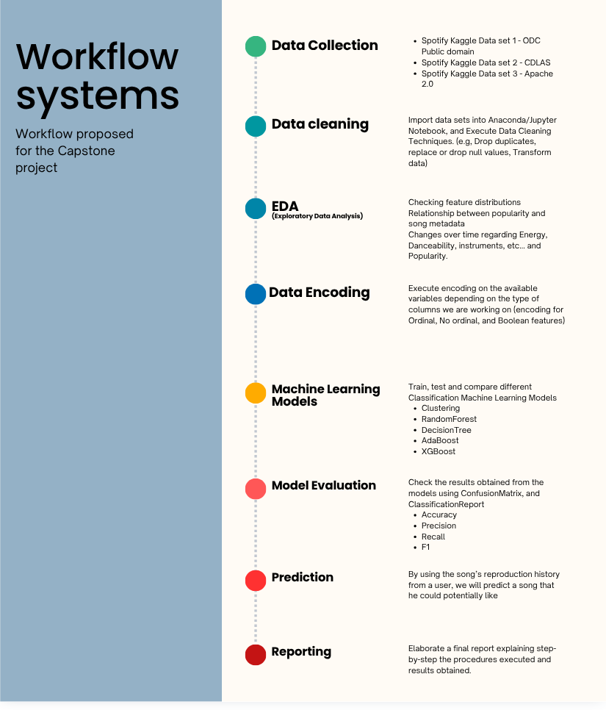
Workflow system image made on Canvas

Data Sources
In my research for different data sources for this project, I have found some really interesting options; I will list them below using bullet points and mentioning their origin.
- Kaggle: Dataset 1. It’s a CSV file with over 20,000 records of song metadata, such as energy, danceability, loudness, and duration. The dataset is licensed under the ODC Public Domain Dedication and License (PDDL), meaning that it is free of copyright restrictions and available for use in my project. The file has key variables for building my recommendation system.
- Kaggle: Dataset 2. It’s also a CSV file with nearly 600,000 records featuring song metadata. The dataset is licensed under the Community Data License Agreement – Sharing, Version 1.0, meaning it’s copyright-free and I can use it for my project and for training my machine learning models.

Expected Deliverables
I can split the expected deliverables by the end of semester 2 into 3 different sections:
- Analytical Results: I should have cleaned my data, conducted an Exploratory Data Analysis, looked for insights, and potentially identified patterns using pivot tables, charts, correlation plots, and distributions.
- Predictive Modelling Outputs: With my data cleaned, I should be ready to execute encoding as specified above with the mentioned techniques (Label Encoder, Mapping, and One Hot Encoder); in order to train, test and evaluate my models, comparing the results obtained on Accuracy, Recall, Precision, and F1 to identify the best model.
- Final Report: A well-detailed report explaining step-by-step how I handle the data, the methods used, the challenges confronted during the process, the results obtained from the machine learning models and the final selection with an explanation of why.

Project Timeline
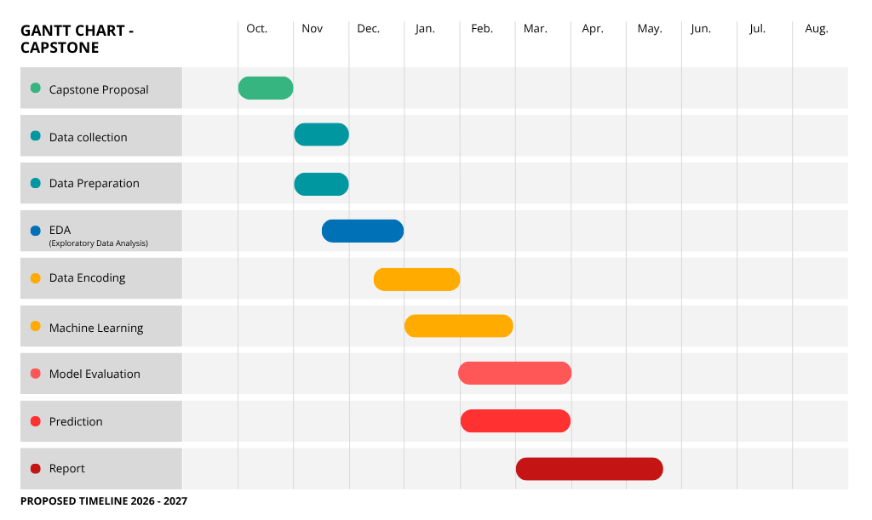

Ethical and Legal Considerations
- Intellectual Property and Data Licensing
Based on the research I have completed so far, I can confirm that all datasets are copyright-free and can be used for my project.
The data was acquired from public repositories (Kaggle.com and Data Search Google), under open data licenses, such as:
- ODC Public Domain Dedication and License (PDDL);
- Community Data License Agreement – Sharing, Version 1.0
- Data collected
The data collected/obtained does not contain any type of personal data through which a person can be identified. For example:
- Name
- Date of birth
- Email Address
- Phone number
- Address
- Physical Characteristics
- Location Data

References

Strategic Thinking Module (2026). Week 3: Class notes. CCT College Dublin (22nd of October 2026)
Strategic Thinking Module (2026). Week 4: “Data Protection and Privacy GDPR”. CCT College Dublin
(22nd of October 2026)
Sanjana chaudhari☑️ (2023). Spotify dataset. [online] Kaggle.com. Available at: https://www.kaggle.com/datasets/sanjanchaudhari/spotify-dataset [Accessed 22 Oct. 2026].
Eren Ay, Y. (2022). Spotify dataset 1921-2020, 600K+ tracks. [online] kaggledatasets. Available at: https://www.kaggle.com/datasets/yamaerenay/spotify-dataset-19212020-600k-tracks [Accessed 22 Oct. 2026].

Appendix
I have used AI for the purpose of checking for grammatical mistakes, typos, commas, and punctuation. Bellow I will add a screenshot of the requested prompt:

